**Intern Details**  
**Name:** Swarn Ranjan  
**Internship Duration:** 06th May 2025 – 30th June 2025  
**Institution:** Kalinga Institute of Industrial Technology  
**Mentor:** Dr. Tarun Yadav, Scientist-F, SAG, DRDO, New Delhi  
**Reporting Period:** Week 6 (05/06/2025 – 19/06/2025)

**1. Topics Covered**

This week focused on enhancing the secure chat application by introducing RSA-based message authentication and automatic RSA key pair management. Notable improvements include:

* Automatic RSA key generation for new users if key files are missing.
* Secure public key transmission to the server upon client connection.
* Message and file integrity verification using SHA-256.
* Digital signature verification on the server to authenticate message origin.
* Modular improvements in client.py for usability and trust establishment.
* Persistent key storage in .pem format per user.

**2. Resources Utilized**

• PyCryptodome documentation – RSA key generation and signature APIs

• PyQt5 documentation – GUI widget layout, events, threading

• NIST SHA-256 specification

• Python socket and threading modules

• Stack Overflow and GitHub for implementation strategies

**3. Key Learnings**

**•** RSA **Key Lifecycle**: Understood how to generate, store, and use RSA key pairs for signing and verifying messages.

• Signature **Authentication**: Implemented and tested digital signatures to validate message origin and detect tampering.

• Hybrid **Cryptographic Systems**: Combined AES (confidentiality), SHA-256 (integrity), and RSA (authenticity) effectively.

• GUI **Engineering**: Learned how to build responsive GUI applications using PyQt5 to interface with backend logic.

• Usability **and UX**: Improved overall user experience by allowing chat clients to communicate with usernames and structured interactions.

**4. Project Status**

The secure chat system is now feature-complete for core objectives:

* Secure text and file transfer using **AES-CBC encryption**
* SHA-256 hashing to **verify message and file integrity**
* **RSA digital signatures** to ensure message authenticity
* **Automatic RSA keypair generation** on client side
* **Graphical interface** using PyQt5 for:
  + Connecting with username
  + Sending/receiving encrypted messages and files
  + Real-time updates in a chat-style interface
* Server validation for public keys and signature checks
* Refactored architecture with clear modular files:

server.py, client_logic.py, crypto_utils.py, chat_gui.py

**5. Code Snippets**

Automatic RSA Key Generation:

 if not (os.path.exists(privkey_path) and os.path.exists(pubkey_path)):

            print(f"[KEYGEN] RSA keys not found for '{USERNAME}'. Generating...")

            key = RSA.generate(2048)

            with open(privkey_path, "wb") as priv_file:

                priv_file.write(key.export_key())

            with open(pubkey_path, "wb") as pub_file:

                pub_file.write(key.publickey().export_key())

            print(f"[KEYGEN] Keys saved as '{privkey_path}' and '{pubkey_path}'.")

Digital Signature Function:

def sign_data(data: bytes, private_key_path: str) -> bytes:

    key = RSA.import_key(open(private_key_path).read())

    h = SHA256.new(data)

    signature = pkcs1_15.new(key).sign(h)

    return signature

Signature Verification:

def verify_signature(data: bytes, signature: bytes, public_key_path: str) -> bool:

    key = RSA.import_key(open(public_key_path).read())

    h = SHA256.new(data)

    try:

        pkcs1_15.new(key).verify(h, signature)

        return True

    except (ValueError, TypeError):

        return False

PyQt Message Handler:

 def send_message(self):

        if not self.chat_client:

            return

        message = self.message_input.text().strip()

        recipient = self.recipient_input.text().strip()

        if message and recipient:

            self.chat_client.send_message(recipient, message)

            self.chat_log.append(f"You to {recipient}: {message}")

            self.message_input.clear()

**6. Outputs**

GUI output:

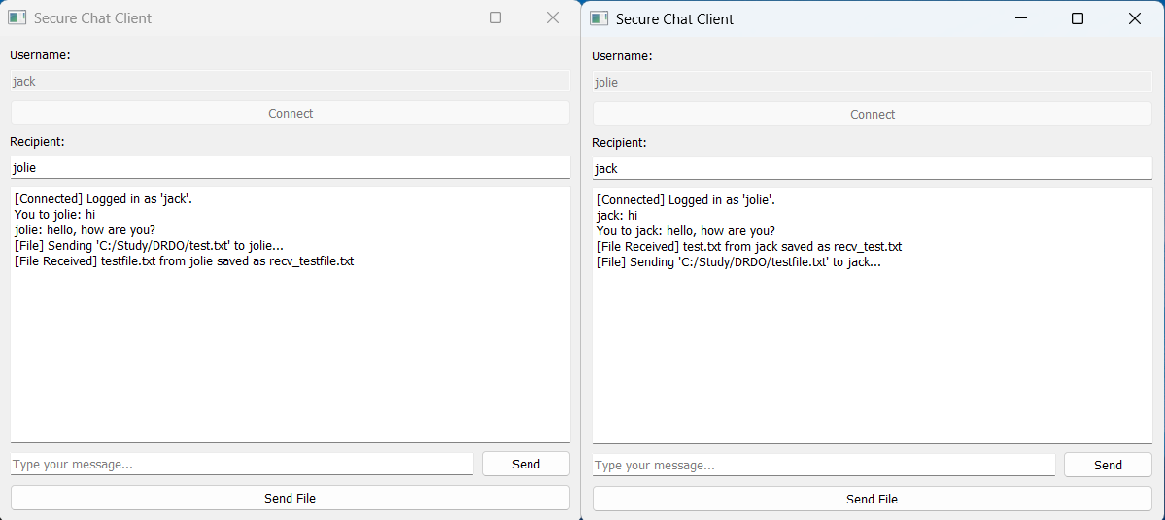

(Swarn Ranjan)